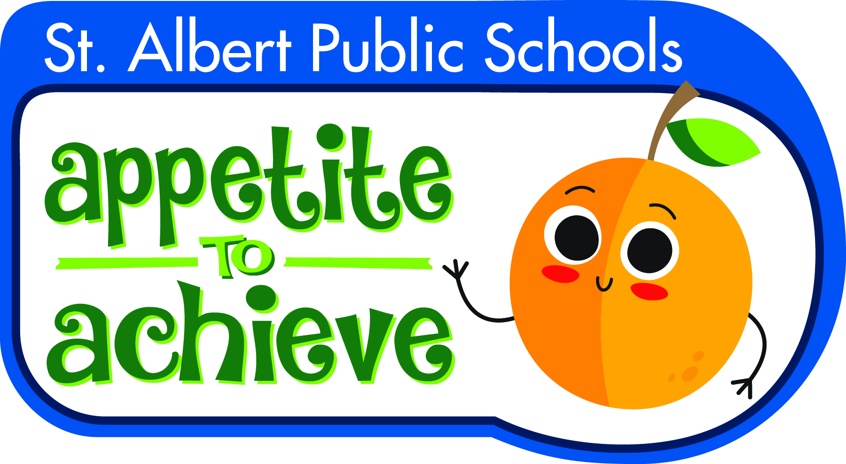[](http://www.crsadmin.com/EventPortal/Registrations/PublicFill/EventPublicFill.aspx?evtid=f1016b63-44c8-4d90-bae3-7a28f52e2495)

[**www.saintcityrotary.org**](http://www.saintcityrotary.org)

[**https://www.crsadmin.com/EventPortal/Registrations/PublicFill/EventPublicFill.aspx?evtid=ec5a167c-d772-48ee-8f56-17ef8cf98e89**](https://www.crsadmin.com/EventPortal/Registrations/PublicFill/EventPublicFill.aspx?evtid=ec5a167c-d772-48ee-8f56-17ef8cf98e89)

**Some of our local projects include:**

**Last Year within St. Albert Schools we helped provide Breakfast, Lunch and/or snacks to over 800 students in need, supported Clean Scene (Drug Awareness Program) and Youth Programs.**

$160/golfer Contest Passport $40

Includes: Breakfast, Gift, Complimentary use of driving range, round of golf with power cart and a Steak Dinner

*Golfers, Sponsors, Donations and Prizes*

*Needed to Help Make Dreams Real!*

Register Online

**Saint City Rotary Charity Golf Classic**

**Thursday, August 15, 2019**

**Sandpiper Golf & Country Club**

***TEXAS SCRAMBLE***

**6:30 AM Registration/Breakfast 8 AM Shotgun start**

***Proceeds Support Saint City Rotary Projects***